A cyst is a fluid-filled sac also known as a blocked milk duct. The fluid occurs in the breast as part of the usual cycle of hormonal breast changes. Some women are more susceptible to breast cysts than others, and commonly found:
- In women aged 35-50
- and in women who are taking hormone replacement therapy.
The causes of changes in your breasts are:
- Most commonly hormonal changes related to your menstrual cycle,
- pregnancy,
- menopause
- and changes due to ageing.
Diagram of a breast containing breast cysts: 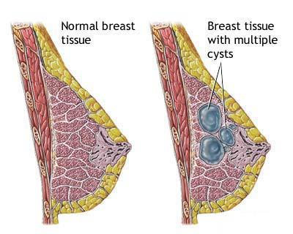
https://www.women-info.com/en/breast-cysts/
Simple cysts are not cancerous and do not change into cancer.
Many women have cysts and are unaware of them, until they become palpable or painful where they can decide to aspirate if it gets painful or too large and affects confidence in self-examination.
Aspirations are usually painless and involves:
- inserting a fine needle into the cyst
- draining the fluid.
- The aspirate is sent to pathology to check for any bacteria for possible antibiotics if needed.
Any women with a new lump should consult her GP and never assume it’s a cyst. The GP will examine her and/or arrange an ultrasound rule out any suspicious findings.

